Aerospace Support International concludes Dunlop & Goodyear tyre deal.
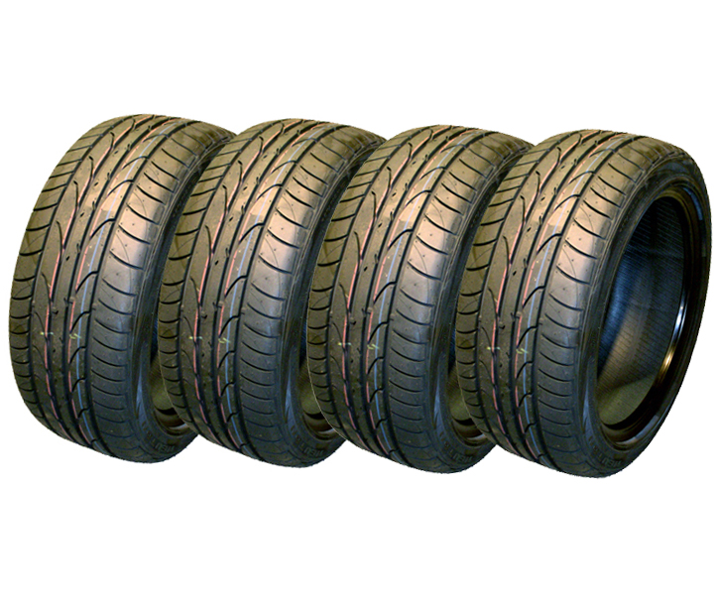
Aerospace Support International is proud to announce its sale of Dunlop & Goodyear Tyres for BAE-146 & Boeing 737-300 Nose & Main Wheels value US$ 90,000.00
Aerospace Support recently concluded its sale of Dunlop & Goodyear tyres Qty 90 consisting of DR15840T (24X7.7), DR25821T (27X7.75-15) & DR11748T (39X13) and Goodyear Tyre 419K62T2 (40X14.5-19) to a major airline operator.
Please contact us for all your Tyre needs

